

**Blood Pressure Monitor Desktop Application**

**Software Workshop Team Project**

Group Raleigh

Abdullah ALI 1848984 [axa1303@student.bham.ac.uk](mailto:axa1303@student.bham.ac.uk)

Shukri ALI 1083327 [saa727@student.bham.ac.uk](mailto:saa727@student.bham.ac.uk)

Thomas CUNNINGHAM [txc754@student.bham.ac.uk](mailto:txc754@student.bham.ac.uk)

Xumin DING 1854515 [xxd715@student.bham.ac.uk](mailto:xxd715@student.bham.ac.uk)

Xinyi SUN 1786228 [xxs728@student.bham.ac.uk](mailto:xxs728@student.bham.ac.uk)

19th March 2018

School of Computer Science

University of Birmingham

Birmingham, B15 2TT

**Abstract**

Blah, blah,blah…

**Statement of Contribution**

All team members have agreed with the following contribution on the software workshop team project that they worked on with:

Abdullah ALI: %

Shukri ALI: %

Thomas CUNNINGHAM: %

Xumin DING: %

Xinyi SUN: %

Signatures: Abdullah ALI, Shukri ALI, Thomas CUNNINGHAM, Xumin Ding, Xinyi SUN

**Table of Contents**

1. Overview 2

1.1 System Description 2

1.2 Background Research 3

1.3 Requirements 6

1.4 Prototype 8

2. System Design 11

2.1 Whole system 11

2.2 Database 12

2.3 Server 13

2.4 Client 14

2.5 Graphical User Interface (GUI) 15

3. Testing 16

3.1 Functional Tests 16

3.2 Junit Tests 19

4. Team Organisation 20

5. Evaluation 21

# 1. Overview

# 1.1 System Description

Blah,blah,blah...

# 1.2 Background Research

Blood pressure is represented by two values. The systolic blood pressure, which is the pressure that the blood is forced through the blood vessels during a heartbeat, and the diastolic blood pressure, which is the pressure in blood vessels between heartbeats. Hypertension, also commonly known as high blood pressure is when either one, or both numbers are abnormally high. Estimates show that around 40% of the world's population has hypertension[1], which is an enormous amount. Hypertension is a precursor to many life-limiting conditions like heart failure and kidney failure, so it is important to screen people regularly for this condition and to manage them appropriately.

Blood pressure measurements are difficult to record accurately in a clinical setting, as the anxiety and stress of the experience tends to give inaccurately high readings[2]. Therefore, to diagnose and manage hypertension, patients are required to monitor their readings at home for a given period; the average of which is used to confirm the diagnosis of hypertension.

Current guidelines suggest that a patient should record at least 2 consecutive readings, twice a day, for ideally 7 days (a total of 28 readings)[3]. Currently, most patients are given a paper diary, on which they record their blood pressure readings. The paper is then handed to a clinician, whom then manually uses those readings to calculate the average and determine whether the patient meets the criteria for confirmation of a hypertension diagnosis. As one can imagine, this is not only wasteful of resources like paper and printing but is also wasteful of the clinician and patient's time. By digitalising this process, we can save the time taken for the patient to manually take the readings back to the clinician, and for the clinician to manually calculate the average. Not to mention eliminating the risk of the patient losing their diary.

Existing Products Review

In this section, I aim to analyse products and services currently available, for home BP monitoring. A point to be noted is that none of the products were found to solve the main problem we identified, which was of being able to transfer the readings directly to the clinician.

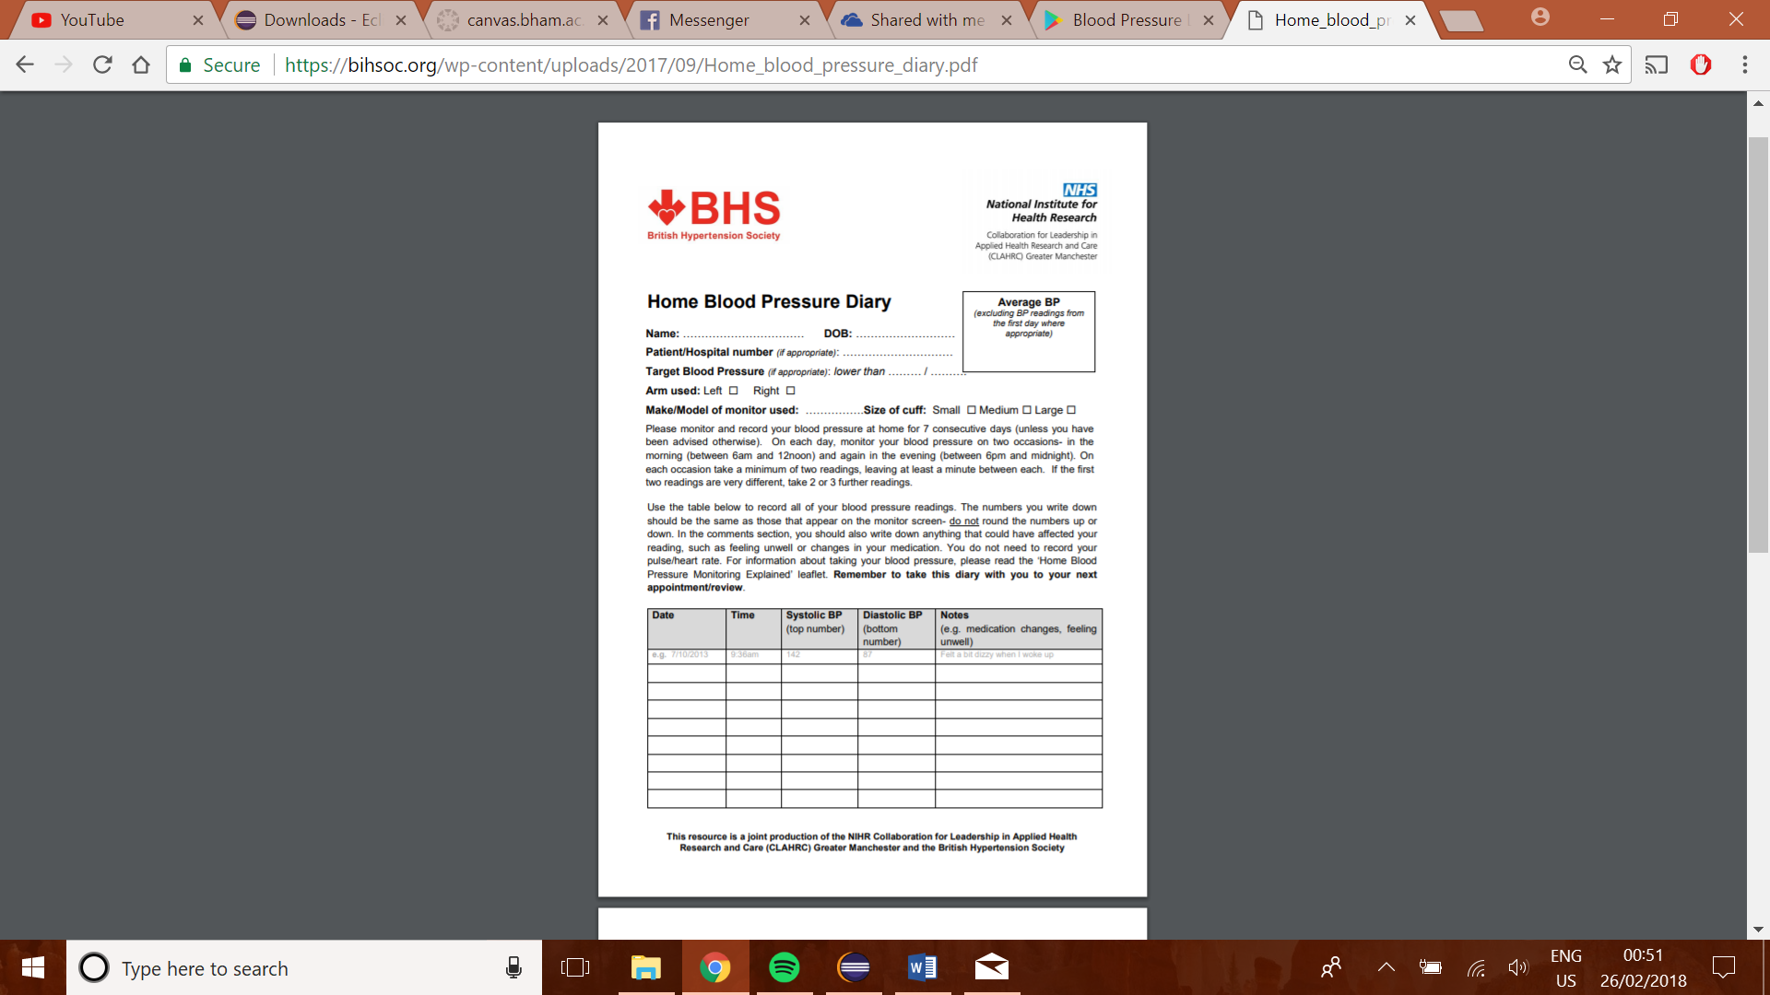Product 1: Paper Diary[4]

This is a paper diary for home BP recording. This is created by a leading Hypertension authority and most clinicians today use this or a variation on this style of paper diary.

Pros:

* Instructions on how to record the readings, written clearly; by experts in the field.
* Easy to use, with clear indication of how exactly to fill in the form, with addition of a comments section for any extra comments about that reading.
* Secure (can't be hacked)

Cons:

* Requires readings to be manually inputted and the average to be manually calculated
* Is not able to show visually, the patient's blood pressure trends.

Product 2: Blood Pressure Log – MyDiary (Android App)[5]

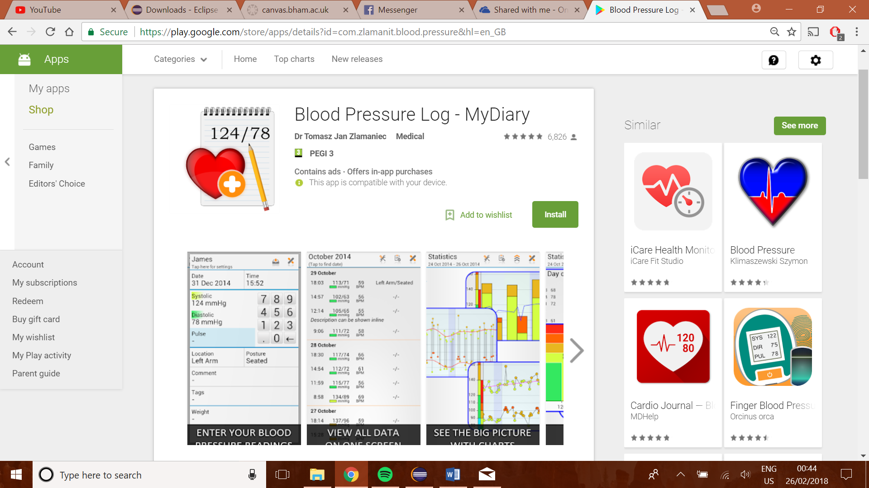This is an android app which can be used as a diary. This allows us to record blood pressure readings, which can then be displayed numerically, as well as graphically.

Pros:

* Patient can easily enter their readings
* Readings are represented visually as graphs of trends over time
* Extra information like location, posture, weight, and comments can also be added.

Cons:

* Very cluttered interface
* No way of transferring the readings across to the clinician

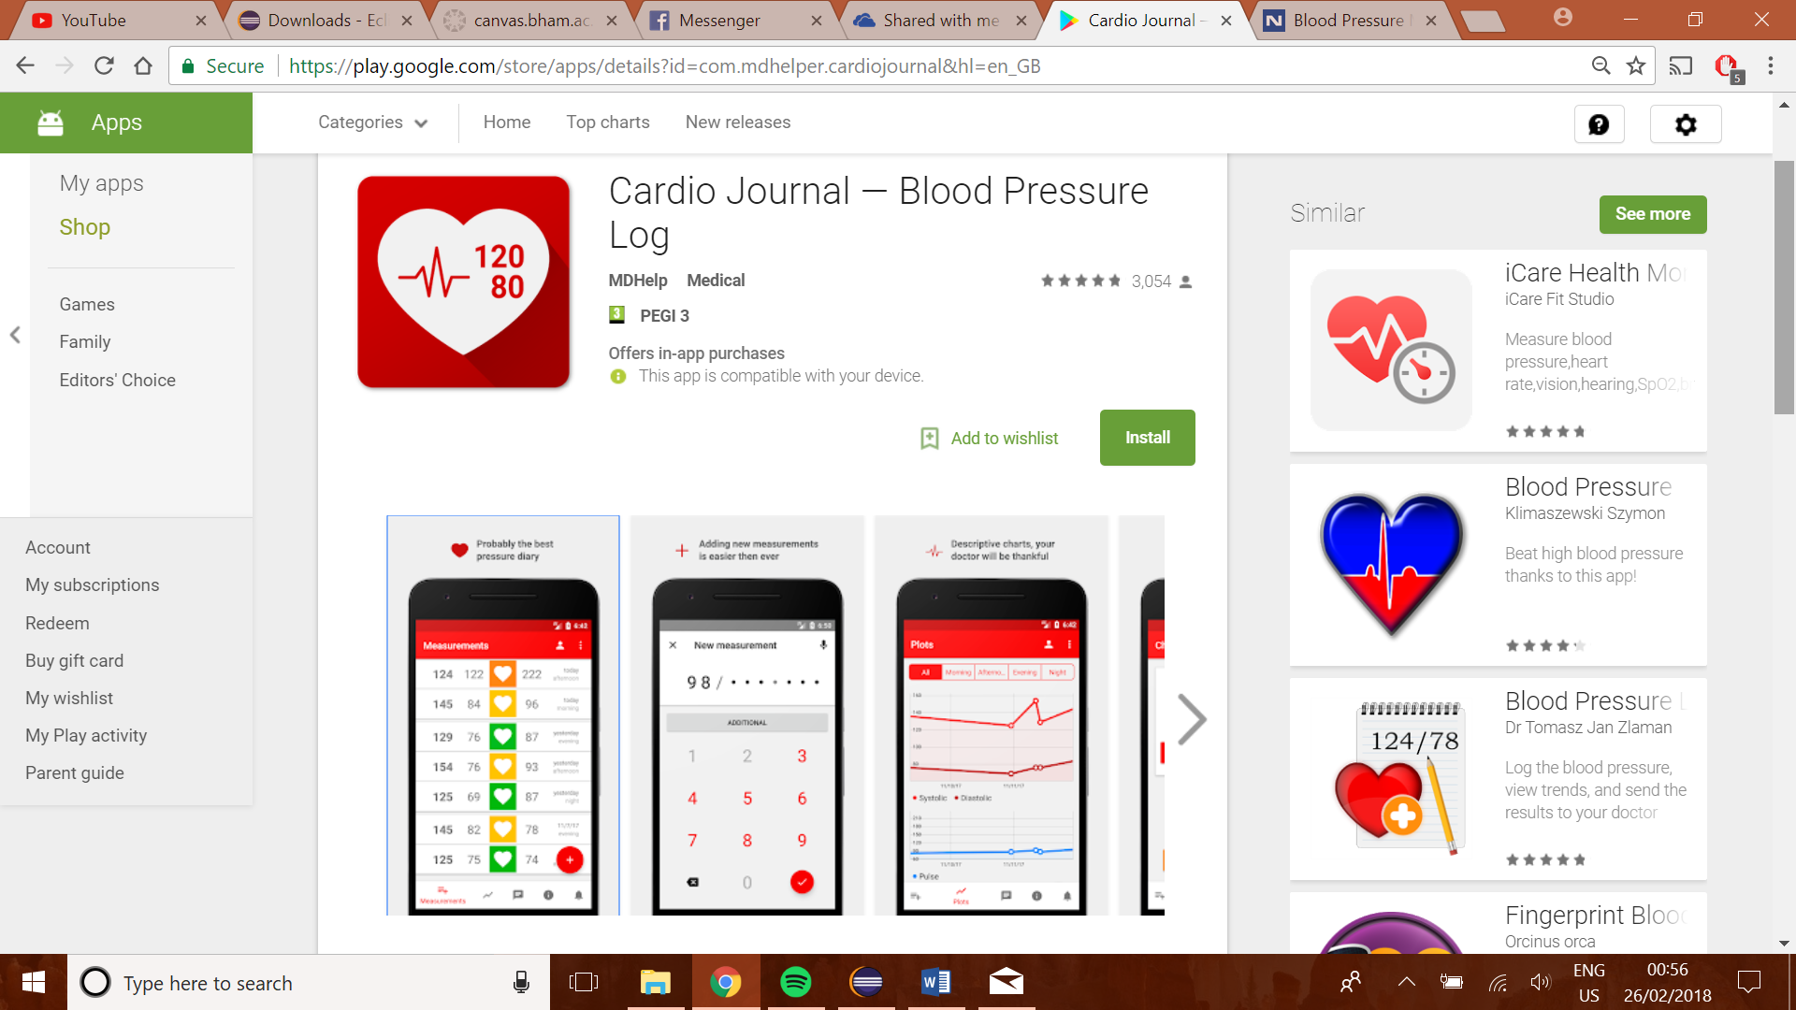Product 3: Cardio Journal – Blood Pressure Log (Android App)[6]

Pros:

* Very simple and visually pleasant graphical user interface
* numerical display for inputting readings, to prevent entering of invalid characters or in an invalid format.

Cons:

* This app also does not provide a feature for sending the readings to the clinician automatically.
* The app provides no information on how to take readings appropriately as well as when to take them.

In summary, research into existing systems has been very informative in highlighting features which will be potentially very useful in our project. It highlighted that the unique feature of our app will be the connectivity with the clinician, so this should be our main focus. We also realised that while the app should be clear and informative, it should also have a clean GUI which is easy to use and navigate.

# 1.3 Requirements

Functional

1.3.1 User login

* For login purposes, the system shall require the user to input his/her username and correct password.
* The system shall notice the user to try again account, when they wrongly input username or password, and show “wrong username or password!”.
* The system should check if the user has signed up, if not, show “user not existed.”
* The system should distinguish users from doctor and patient. The doctor should log into the doctor’s home page, while the patient should log into the patient’s home page.

1.3.2 Patient

* The app should enable the patient to update his/her blood pressure readings, with uploading date and time.
* The database must be able to store patient blood pressure readings.
* The app should enable the patient to input their blood pressure reading up to 3 times for each measure.
* The app should enable record all readings of patient that he/she has uploaded so far and present them both in a chart to show a tendency.
* The app should enable patients to set a target blood pressure reading, both in text and chart.
* The app should enable automatic calculation of average value of all blood pressure readings they have uploaded and present it both in text and chart.
* The app should enable automatically update reading left once the patient upload his/her readings and present it in text.
* The app should enable patients to write comments and upload it.

1.3.3 Doctor

* The app should allow doctors generates a new patient that contains all his/her information.
* The database must be able to store basic patient information.
* The system should generate username and password of patients automatically when the doctor adds a new patient.
* The app should enable doctors to search a patient by his/her name, and show their name, date of birth, and address in a patient list.
* The app should enable show the completed patients in the competed list.
* The app should enable doctor to choose a patient showed in both lists by double click, and there should be a new window contains information (name, readings, etc.) of this specified patient.
* The app should enable to generate PDF of patient information showed in patient view.

Non-functional

* (Efficiency) The application shall provide a response to user input within 1 second.
* (Security) The application shall ensure the all the information (including users’ personal information, patients’ readings etc.) can only be accessed by the patients themselves and their corresponding doctors.
* (Availability) The application should be able to access at any time as long as users need.
* (Capacity) The system must enable concurrently support for multi users at a time.

# 1.4 Prototype

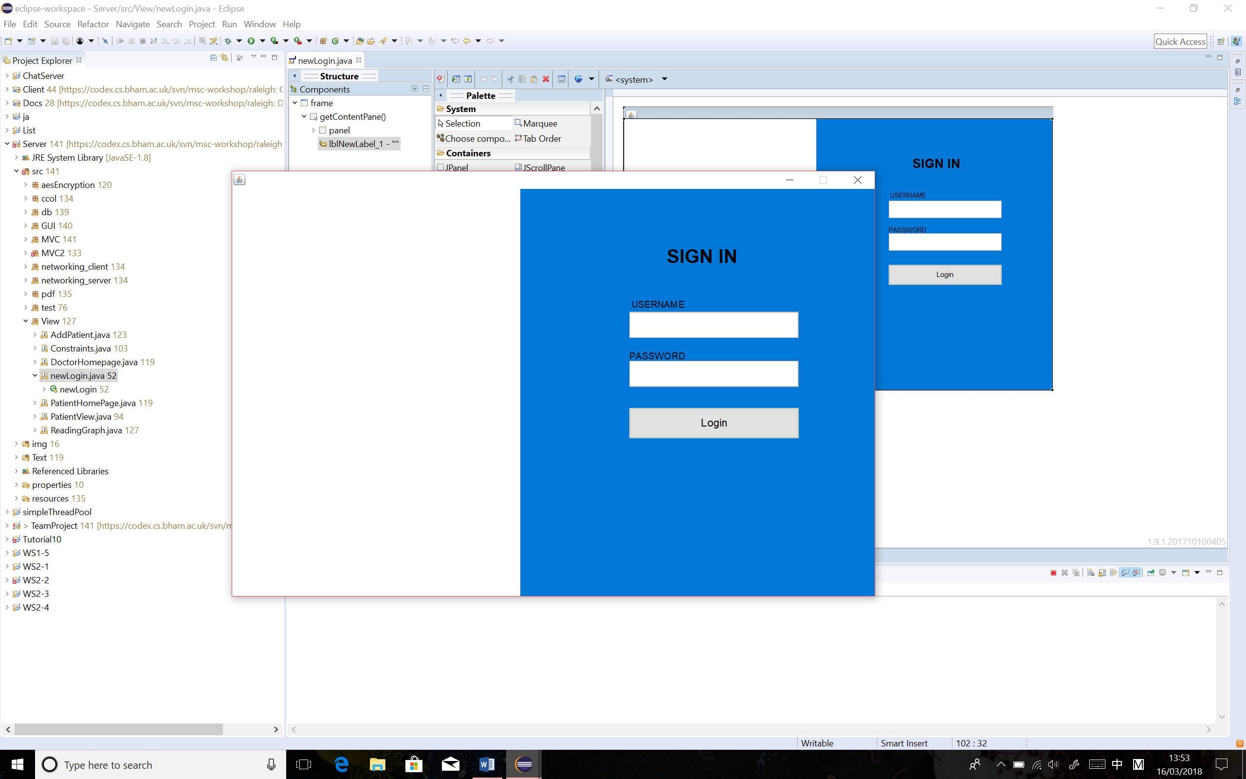The initial prototype was built up to visualise the concept of the blood pressure monitor desktop application, based on the requirements which were proposed at the early stage of the whole project. The prototype of this application would include a user log in page that requires users, in this case would be either patients or doctors, to log in the application using their own username and password. (See Figure 1)

Figure 1 Prototype of User Login Page

Once patients/doctors log in successfully, another window will be opened to display their homepages, which varies from the type of users. The registered doctors will see the doctor homepage and the registered patients will be given the patient homepage.

On the patient home page, a relevant video and readable guidance are provided to help patient understand how to use the blood pressure monitor. The BP target that was prescribed by the doctors was printed on the screen. After measurements, the patient allows to input and submit the blood pressure readings, along with the recorded time and date, to track the BP trend on a daily base. The BP trend graph will be presented on the top of the page as a real-time update. (See 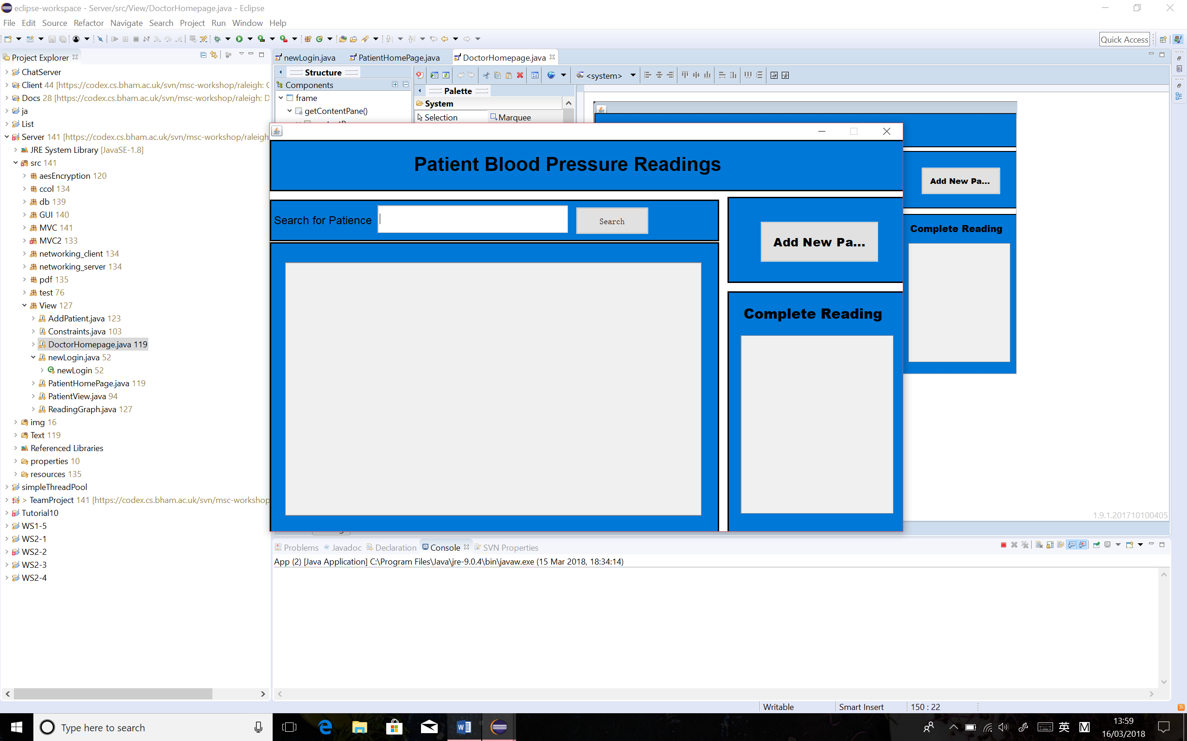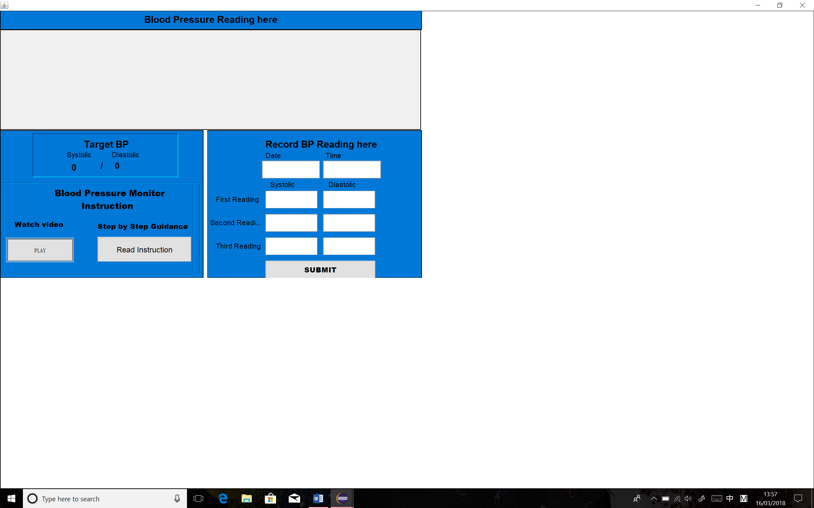Figure 2)

Figure 2 Prototype of Patient Home Page

Figure 3 Prototype of Doctor Home Page

Doctors are permitted to access the registered patients’ details through the doctor home page. From the prototype of doctor home page, it was given the functionality to search existed patients and add new patients. To add a new patient, the doctor needs to click on the “add patient” button, which opens a new window that the doctors can input all the details required for creating a new patient. To read the patient up-to-date blood pressure readings, the doctor can click on the patient he searched, which pops up a new window that displays the most important patient information on the screen, such as patient’s personal details, blood pressure target and date of the last reading etc. The BP reading trend graph that generated on the patient home page was also plotted on this page, sending an idea to the doctor that how the patients’ blood pressure keeps changing over time. Doctors can also view a list of patients who have completed the 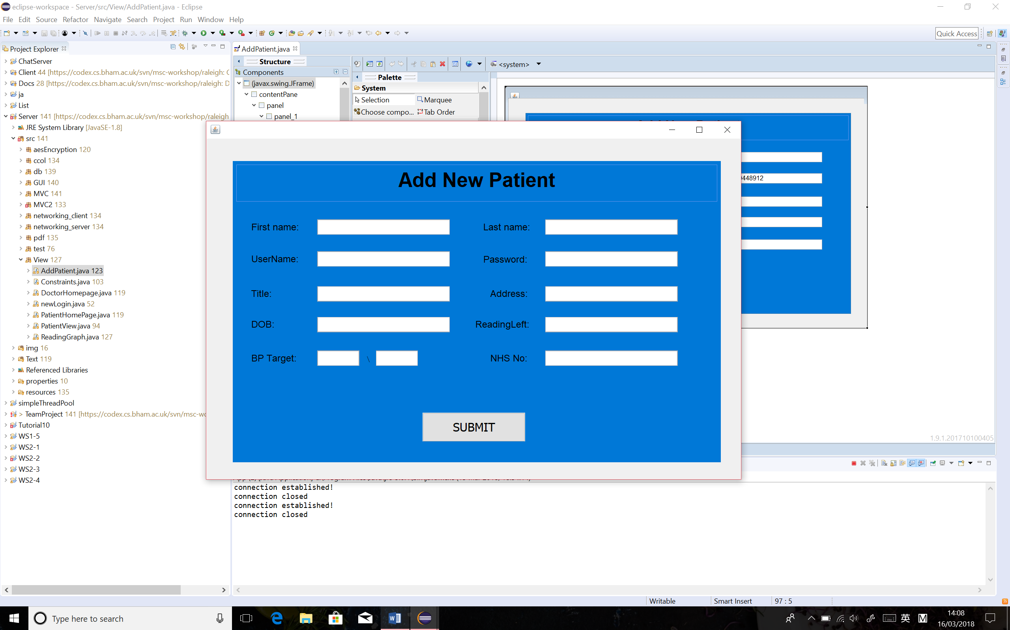prescribed reading amounts on the doctor home page. (See Figure 3, 4 and 5)

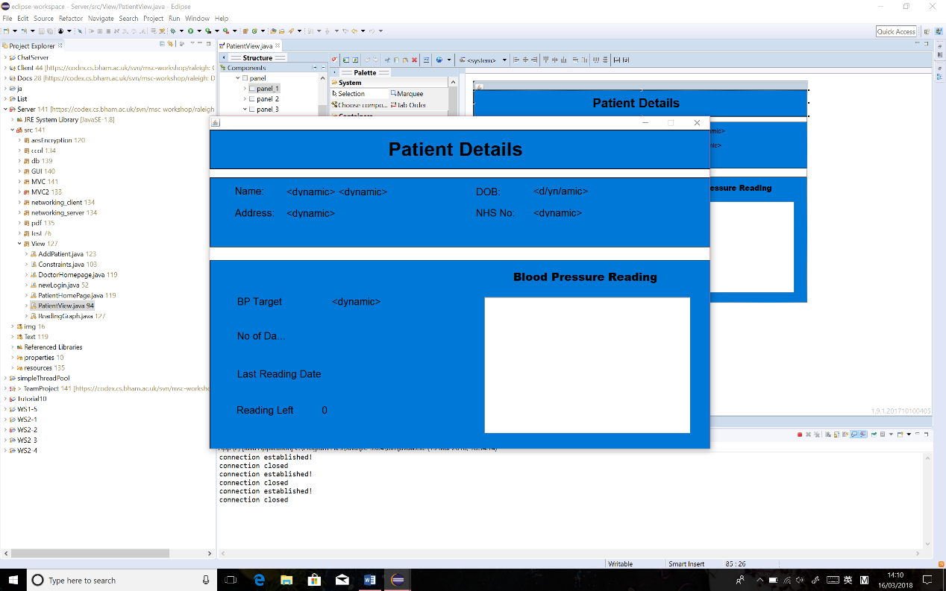Figure 4 Prototype of Add Patient Page

Figure 5 Prototype of Patient Details Page

# 2. System Design

# 2.1 Whole system

Use Case Diagram

# 2.2 Database

# 2.3 Server

# 2.4 Client

# 2.5 Graphical User Interface (GUI)

# 3. Testing

# 3.1 Functional Tests

|  |  |  |
| --- | --- | --- |
| **Test** | **Action** | **Sent requests and expected Response** |
| 1 | On the log in page, click the “login” button with correct username and password. | A user request is sent to server to check the database; the input matches and a response is sent to login into the either a patient home page or a doctor home page. |
| 2 | On the log in page, click the “login” button with incorrect username or password. | A user request is sent to server to check the database; the input does not match, and a response is sent to inform the user that the login has failed with a reason explained in the pop-up window. |
| 3 | On the patient home page, click the “play” button. | A patient request is sent to server, a response is sent back link to the web site where the video is stored. |
| 4 | On the patient home page, click the “Read Instruction” button. | A patient request is sent to server, a response is sent back link to the web site where the instruction is stored. |
| 5 | On the patient home page, select a future date and time that recorded the blood pressure, along with correct inputs in the blood pressure reading fields and click “submit” button. | A patient request is sent to server, a response is sent to warn the patient the submit failed, with a reason of inappropriate date inputs, explained on the pop-up window. |
| 6 | On the patient home page, type non-numerical inputs into the blood pressure readings fields and click “submit” button. | A patient request is sent to server, a response is sent to warn the patient the submit failed, with a reason of wrong format of inputs, explained on the pop-up window. |
| 7 | On the patient home page, type numerical inputs into the blood pressure readings fields, with some empty fields left and click “submit” button. | A patient request is sent to server, a response is sent to warn the patient the submit failed, with a reason of “the field cannot be empty”, explained on the pop-up window. |
| 8 | On the patient home page, type numerical inputs into all blood pressure readings fields, where the systolic is over 300 or less 30 and click “submit” button. | A patient request is sent to server, a response is sent to warn the patient the submit failed, with a reason of wrong inputs, explained on the pop-up window. |
| 9 | On the patient home page, type numerical inputs into all blood pressure readings fields, where the diastolic is over 200 or less 20 and click “submit” button. | A patient request is sent to server, a response is sent to warn the patient the submit failed, with a reason of wrong inputs, explained on the pop-up window. |
| 10 | On the patient home page, input all the blood pressure readings to the corresponding textbox in correct format, along with the recorded date, time and any comments(optional), click “submit” button. | A patient request is sent to server, a response is sent back a “submission success” message in the pop-up window and plot the inputted blood pressure readings on the graph accurately. A latest average blood pressure reading is computed. The screen prints out remaining blood pressure readings for the patient. |
| 11 | When the remaining BP reading says “1” left, input the last readings data into all the fields and click “submit” button. | A patient request is sent to server, a response is sent back a “you have completed all your readings” message in the pop-up window and plot the inputted blood pressure readings on the graph accurately. A latest average blood pressure reading is computed. The screen prints out “0” remaining blood pressure readings for the patient. |
| 12 | When the remaining BP reading says “0” left, input the last readings data into all the fields and click “submit” button. | A patient request is sent to server, a response is sent back a “you already finished your readings” message in the pop-up window. |
| 13 | On the doctor home page, search the patient by typing in an unregistered patient name in the search bar, click “search” button. | A doctor request is sent to server, a response is sent to inform the doctor that the inputted name does not exist in the database in a pop-up window. |
| 14 | On the doctor home page, search the patient by typing in a registered patient name in the search bar, click “search” button. | A doctor request is sent to server, a response is sent to list all the possible search results in the textbox below. |
| 15 | Double click on a registered patient displayed in the result list that the doctor is looking for. | A doctor request is sent to server, a response is sent to open the new window – view patient page, which presents the chosen patient’s personal information collected from the database, including name, DOB, address and NHS number. Each BP reading that patient has entered is listed in the right bottom box in detail. The target, average BP, highest BP, lowest BP and remaining BP readings will be computed and displayed on the left bottom. An up-to-date patient BP trend graph is plotted in the middle of the page. |
| 16 | On the view patient page, click “generate PDF” button. |  |
| 17 | On the doctor home page, click the “add patient” button. | A doctor request is sent to server, a response is sent to open add new patient page in a new window. |
| 18 | On the add patient page, input the information with some empty fields left and click “submit” button. | A doctor request is sent to server, a response is sent to warn the doctor that the submission is failed, with a reason of “the field cannot be empty”, explained on the pop-up window. |
| 19 | On the add patient page, input the first name of the new patient in illegal format whilst all the other information is correctly entered, click “submit” button. | A doctor request is sent to server, a response is sent to warn the doctor that the submission is failed, with a reason of “the first name must be between 1 to 30 characters, explained on the pop-up window. |
| 20 | On the add patient page, input the last name of the new patient in illegal format whilst all the other information is correctly entered, click “submit” button. | A doctor request is sent to server, a response is sent to warn the doctor that the submission is failed, with a reason of “the last name must be between 1 to 30 characters”, explained on the pop-up window. |
| 21 | On the add patient page, input the number of readings left as “0” whilst all the other information is correctly entered, click “submit” button. | A doctor request is sent to server, a response is sent to warn the doctor that the submission is failed, with a reason of “the number of readings left must be between 1 to 30”, explained on the pop-up window. |
| 22 | On the add patient page, input the systolic of BP target as “400” whilst all the other information is correctly entered, click “submit” button. | A doctor request is sent to server, a response is sent to warn the doctor that the submission is failed, with a reason of “the systolic must between 30 to 300”, explained on the pop-up window. |
| 23 | On the add patient page, input the diastolic of BP target as “300” whilst all the other information is correctly entered, click “submit” button. | A doctor request is sent to server, a response is sent to warn the doctor that the submission is failed, with a reason of “the systolic must between 20 to 200”, explained on the pop-up window. |
| 24 | On the add patient page, input all the patient information to each corresponding textbox in correct formats, click “submit” button. | A doctor request is sent to server, a response is sent to generate a new patient, in the database and the new patient allows to log in to the application with correct username and password. |

# 3.2 Junit Tests

Blah, blah, blah…

# 4. Team Organisation

# 5. Evaluation

1. http://www.who.int/gho/ncd/risk_factors/blood_pressure_prevalence_text/en/
2. https://www.ncbi.nlm.nih.gov/pmc/articles/PMC1120141/
3. https://www.nice.org.uk/guidance/CG127/chapter/1-Guidance#diagnosing-hypertension-2
4. https://bihsoc.org/wp-content/uploads/2017/09/Home_blood_pressure_diary.pdf
5. https://play.google.com/store/apps/details?id=com.zlamanit.blood.pressure&hl=en_GB
6. https://play.google.com/store/apps/details?id=com.mdhelper.cardiojournal&hl=en_GB